Professional Project Management

|  |  |
| --- | --- |
| Student names / ID numbers: | Bui Trung Hieu/ 001323806  Nguyen An Nhat Huy/ 001323809  Huynh Hoang Tuan Anh/ 001323726 |
| Module: | COMP1770 |
| Academic year: | 2023-2024 |
| Project title: | Professional Project Management |
| Submission Date |  |

# Section A

1. **Introduction**

Reacting to changing consumer preferences as well as the obstacles presented by the worldwide pandemic and internet competition, well-known regional coffee firm Roasted Beans has started a revolutionary journey called "Professional Project Management." The goal of this project is to digitally transform Roasted Beans' business practices. It includes creating a mobile application, an online store, and digital marketing plans. The initiative, which has a strict six-month schedule and a £300,000 budget, is motivated by the desire to increase online sales revenue by thirty percent at the expense of consumer interaction and regulatory compliance. Roasted Beans is dedicated to using its well-established reputation and seasoned management team to overcome the challenges of digital transformation and become a leader in the digital coffee market, even in the face of limited resources.

# Aim of the project

## 2.1. SCOPE of project

Need: Roasted Beans must engage in a process of digital metamorphosis to accommodate evolving consumer inclinations and purchasing patterns, specifically in reaction to the online rivalry and the consequences of the worldwide pandemic.

Scope: The aim of the project is to formulate and implement a comprehensive strategy for the digital transformation of Roasted Beans. This encompasses the establishment of an online commercial platform and a mobile application, as well as the formulation and execution of a digital marketing plan. Furthermore, the project will prioritize the cultivation and sustenance of customer relationships in the digital realm, while ensuring adherence to relevant regulations. The project's success will heavily rely on collaboration with a multitude of stakeholders, including senior management, the IT department, the HR department, the marketing team, the coffee roasting team, suppliers, the local community, and regulatory authorities.

**Deliverables:**

· An e-commerce mobile application operating on iOS and Android platforms.

· Marketing application integrated with CRM system

· Customer relationship management

**Exclusions:**

· Operations and administration of physical stores.

· Detailed regulatory compliance beyond e-commerce and data protection.

· Production of coffee beans.

**Constraints:**

· Budget of £300,000.

· Strict six-month timeline.

· Few resources, especially in terms of labor and knowledge of digital transformation.

**Assumptions:**

· Sufficient participation and cooperation from all project stakeholders.

· Prompt provision of resources and assistance from outside partners and suppliers.

· Regulations did not significantly alter over the project's duration.

## 2.2 SMART objective

The primary aim of the digital transformation initiative at Roasted Beans is to enhance the revenue generated from online sales by 30% within a span of six months from the launch of the e-commerce platform. This objective is specific in nature, as it centers around a distinct outcome - that is, augmenting the revenue generated from online sales. It is quantifiable, with the 30% increase serving as a tangible metric to monitor progress and ascertain success. Considering the ongoing shift towards e-commerce and the exceptional quality of Roasted Beans' products, attaining a 30% surge in sales is considered feasible. Furthermore, this goal is relevant to the overarching objective of adapting to ever-changing consumer preferences and digital market competition. Lastly, it is time-constrained, with a clearly defined timeline of six months for its accomplishment, thus ensuring focused efforts and timely assessment of outcomes.

The secondary objective of Roasted Beans' digital transformation initiative is to enhance customer engagement on the digital platform by increasing the average session duration by 20% within three months of launching the mobile app. This objective is specific, as it concentrates on improving customer engagement metrics, particularly through the increase in average session duration. It is measurable, with the 20% target serving as a clear and quantifiable metric to assess the success of the engagement enhancement efforts. Given the capability to implement interactive features and provide valuable content, achieving this 20% increase in session duration is considered achievable. Furthermore, this objective is relevant to Roasted Beans' overarching goal of fostering a sense of community and personal connection in the digital realm. Lastly, the objective is time-bound, with a defined three-month period for achieving the increase in average session duration, facilitating timely evaluation and adjustment of strategies.

# 3. Stakeholder:

**Internal Stakeholders:**

* Ms. Roberta Beal
* Senior Management
* IT Department
* HR Department
* Marketing Department
* Coffee Roasting Team

These participants are integral members of the organization engaged in the project aimed at the creation of an e-commerce platform. They play a direct role in the achievement of the project and hold a significant stake in its results.

**External Stakeholders:**

* Suppliers
* Coffee Roasting Community

These stakeholders are outside the organization but are still impacted by the project.

* Suppliers:The provision of products for sale on the platform can result in potential benefits for the providers, as a successful launch of the platform may lead to an increase in sales.
* Coffee Roasting Community: This may encompass prospective clients and key figures within the industry. Although not actively participating in the daily operations of the project, a thriving platform has the potential to benefit them significantly, either through offering a novel avenue for acquiring coffee beans or establishing a channel for fostering community interaction.

Stakeholders power-interest matrix:

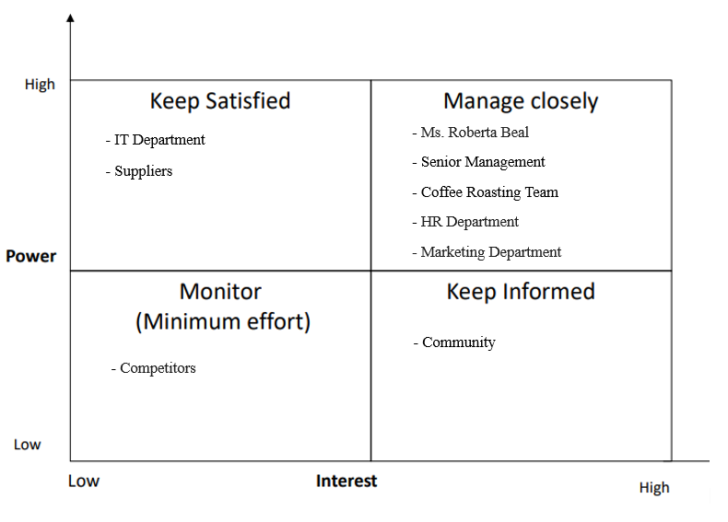

**Communication plan for Roasted Bean:**

**Main Communication Objectives:**

* Build understanding and support from all project stakeholders.
* Provide comprehensive and transparent information about progress and key decisions.
* Create an open communication environment to foster collaboration and feedback from all parties.

**Communication Channels:**

* Regular Information Meetings: Organize regular meetings to update on progress and share information about important decisions.
* Newsletter Emails: Send regular newsletter emails with progress updates and detailed information about next steps.
* Project Website: Develop an internal or public project website to share documents, resources, and updates.

**Communication Targets and Content:**

**Internal Stakeholders:**

Ms. Roberta Beal and Senior Management:

* Provide detailed progress reports and arrange individual meetings to discuss strategic issues and key decisions.

IT Department:

* Provide updates on technical issues and support in platform development.

HR Department:

* Update on HR changes and organize Q&A sessions with employees about the project's impact on their roles.

Marketing Department:

* Provide information on marketing strategies and request support from other parties to ensure effective implementation of campaigns.

**External Stakeholders:**

Suppliers and Coffee Roasting Community:

* Send regular emails or newsletters about progress and the benefits that the e-commerce platform brings to them.
* Organize online meetings or events to share information and listen to feedback from them.

**RACI CHART:**

This RACI chart clearly outlines the roles and responsibilities of each stakeholder group for the various tasks and deliverables involved in the digital transformation project. It ensures that everyone understands their level of involvement and accountability, promoting effective collaboration and communication throughout the project lifecycle.

|  |  |  |  |  |  |  |  |  |
| --- | --- | --- | --- | --- | --- | --- | --- | --- |
| **Task**  **Deliverable** | **Roberta Beal (Owner)** | **Senior Management** | **IT Dept. (Grace Wilson)** | **HR Dept** | **Marketing (Tara Singh)** | **Coffee Roasting Team** | **Suppliers** | **Community** |
| Project Planning & Oversight | **A** | **R** | **C** | **C** | **C** | **C** | **I** | **I** |
| Mobile App Development | **I** | **A** | **R** | **C** | **C** | **C** | **C** | **I** |
| Integration with Systems | **I** | **A** | **R** | **C** | **C** | **C** | **C** | **I** |
| Compliance & Legal | **I** | **A** | **R** | **C** | **C** | **C** | **C** | **C** |
| Digital Marketing Application | **C** | **A** | **C** | **C** | **R** | **C** | **I** | **C** |
| Content & Product Listings | **C** | **A** | **C** | **C** | **R** | **R** | **C** | **C** |
| Customer Experience | **A** | **R** | **C** | **C** | **R** | **R** | **C** | **C** |
| Employee Training | **C** | **A** | **C** | **R** | **C** | **C** | **I** | **I** |
| Community  Engagement | **C** | **A** | **I** | **C** | **R** | **C** | **I** | **R** |

# 4. Requirement Prioritised list (RPL)

Before we started developing the blueprint for Roasted Beans' digital transformation project, we needed to clearly define the project requirements and priorities. Below is a summary of the requirements needed prioritized using the MoSCoW method from the information provided in the case.

|  |  |
| --- | --- |
| **Must- have** | **Should- have** |
| - Mobile app integration enables an e-commerce platform that is both safe and easy to use.  -Integration with the systems for order and inventory management already in place.  -Safe mechanism for handling payments.  -Superior product lists and descriptions that, with help from the coffee roasting staff, capture the sensory experience of in-store patrons.  - Adherence to national and local laws governing data privacy and e-commerce. | -Suggestions made to each individual consumer based on their tastes and prior purchases.  -Service subscription for recurrent purchases.  -Loyalty program to provide loyal clients rewards.  -Interesting material created by the marketing team that covers the history, brewing techniques, and culture of coffee.  -Online customer service portals or live chat help. |
| **Could-have** | **Won’t have** |
| -Connectivity with social media networks for easy advertising and sharing.  -Use instructive quizzes or gamified components to boost client engagement.  -Online coffee tastings or instructive seminars.  -Use augmented reality (AR) elements to demonstrate the brewing or roasting methods. | -Implementing a brick-and-mortar store locator within the e-commerce platform (physical stores remain a core value).  -Developing a delivery service that competes with established delivery partners (focusing on integration with existing services is a better use of resources). |

# 5. Delivery Plan

**Work Breakdown Structure (WBS)**

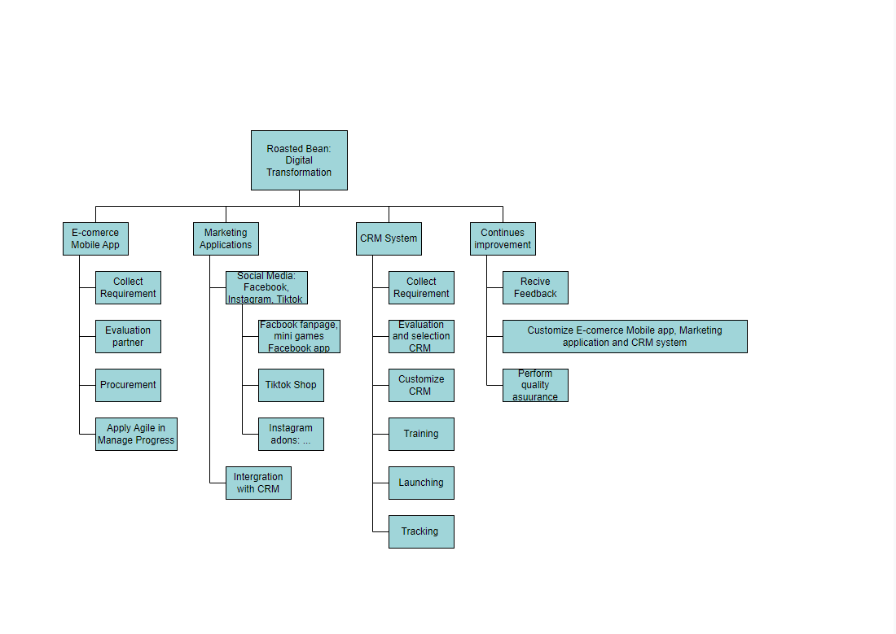

**Gantt chart**

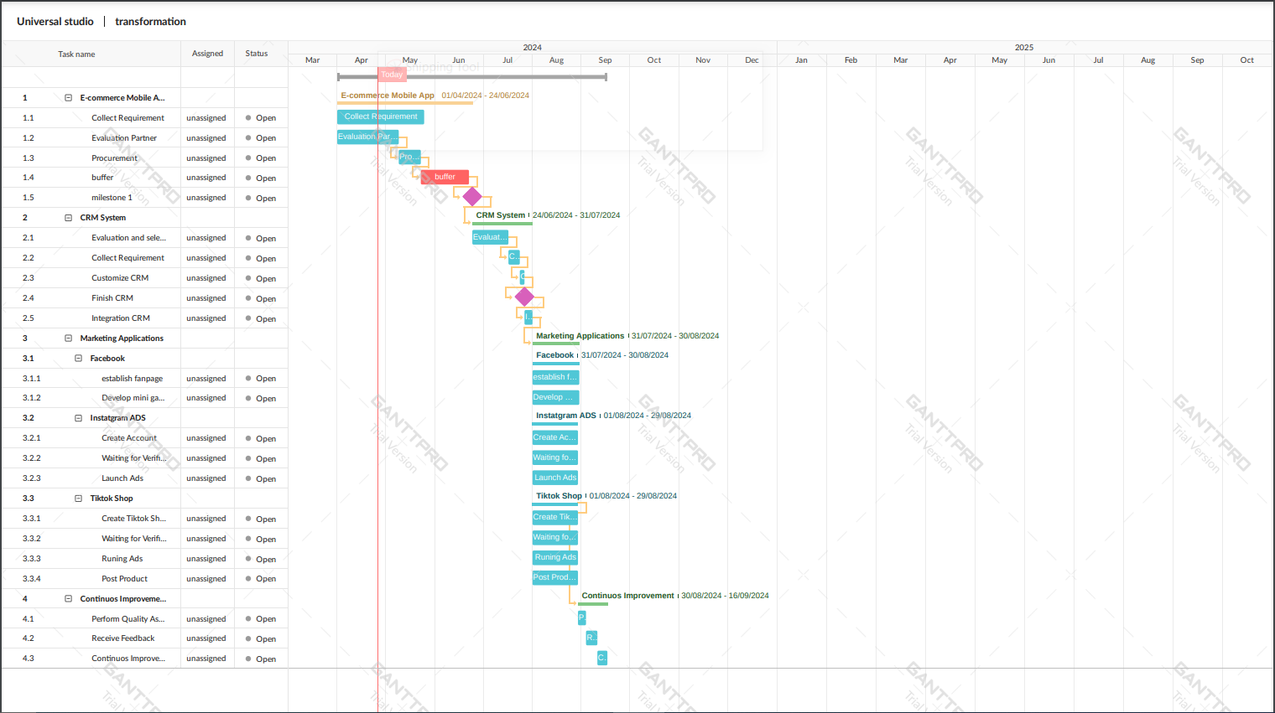

# 6. Project Risk

## 6.1 SWOT Analysis

SWOT is an acronym for Strengths, Weaknesses, Opportunities, and Threats. It's not just about identifying planning and risk areas but also about maximizing project benefits and gaining competitive advantages. It evaluates project activities to optimize potential and identifies risks to determine mitigation strategies (Michelle Symonds, 2014).

Here is the SWOT that we analyzed from the Roasted Beans’s data:

|  |  |  |
| --- | --- | --- |
| Internal | Strengths:  - Established Local Reputation and Customer Loyalty: Established reputation and loyal customer in the local coffee scene  - Substantial Transformation Budget: The allotment of a budget amounting to £300,000 furnishes monetary assets for the process of metamorphosis.  - Experienced Management Team: Experienced senior management team (IT, HR, Marketing) committed to aligning the undertaking with the organizational principles. | Weaknesses:  - Inexperience in E-commerce: Lack of experience in e-commerce.  - Limited Project Timeline: Limited timeframe of six months may increase pressure on project implementation.  - Employee Resistance: Possible opposition to change from employees used to traditional processes. |
| External | Opportunities:  - Market Expansion through E-commerce: Expand reach to a wider customer base through the digital market.  - Brand Promotion on Digital Platforms: Take advantage of digital platforms to promote your brand and attract customers.  - Enhanced Supply Chain Efficiency: Increased efficiency in inventory management and supply chain operations. | Threats:  - Delay In Vendor Selection: Delay in vendor selection may result in missed deadlines.  - Breach Of Data Security: Risks to user information and data protection in e-commerce activities.  - Competitive Pressure from Online Retailers: Competition from online coffee retailers and subscription services.  - Violates Local And Related Laws: The compliance with regulatory conformity requirements and the complex legal complexities in digital transactions. |

## 6.2 Risk Register

**1) Qualitative Risk Register**

From the SWOT analysis of Roasted Beans, we proceed to create a Risk Register, combining strengths and weaknesses with identified opportunities and threats. This allows us to develop detailed response plans for each risk, from technical to organizational, with the goal of improving project efficiency and minimizing risk:

|  |  |  |  |
| --- | --- | --- | --- |
| **Risk ID** | **Risk name** | **Risk description** | **Risk Category** |
| 1 | Inexperience in E-commerce | Roasted Beans may face challenges in implementing effective e-commerce strategies because of expertise and lack of familiarity with this change. | Capability |
| 2 | Limited Project Timeline | Short timelines can put pressure on the project team to deliver results quickly, potentially leading to rushed, flawed or incomplete implementations. | Time |
| 3 | Employee Resistance | Long-term employees may resist adopting new digital technologies and processes, which can hinder digital transformation initiatives. | Organizational |
| 4 | Delay In Vendor Selection | The process of selecting and onboarding vendors for a good mobile app development took longer than expected. | Project Management |
| 5 | Breach Of Data Security | Roasted Beans may be subject to cybersecurity risks and data breaches as a result of managing user information and data in e-commerce operations. | Security |
| 6 | Technical Issues And System Failures In Mobile App | The management of user data and information within e-commerce operations could potentially subject Roasted Beans to risks pertaining to cybersecurity and breaches of data. | Technical |
| 7 | Violates Local And Related Laws | Roasted Beans must ensure compliance with various regulatory requirements and legal complexities related to e-commerce activities. | Regulatory |
| 8 | Market Expand And Brand Promotion | Roasted Beans' digital transformation initiative may lead to increased brand recognition and customer loyalty as a result of improved online presence and customer engagement. | Market |

**2) Risk Response Strategies**

|  |  |  |  |  |  |
| --- | --- | --- | --- | --- | --- |
| **Risk ID** | **Risk name** | **Strategies Type/ Rate** | **Likelihood** | **Impact** | **Response plan** |
| 1 | Inexperience in E-commerce | Mitigate/ Negative | Medium | Medium | Provide training and education to employees on e-commerce best practices and may hire outside experts with expertise in these areas. |
| 2 | Limited Project Timeline | Mitigate/ Negative | High | High | The project team will break down project tasks into manageable milestones with clear deadlines, prioritizing tasks based on their impact in achieving project goals. The project team will allocate resources effectively and consider extending time if necessary. |
| 3 | Employee Resistance | Mitigate/ Negative | Medium | Medium | Develop a comprehensive change management plan, including employee training, and incentives for embracing new processes. Engage employees in the decision-making procedures and attend to their issues. |
| 4 | Delay In Vendor Selection | Mitigate/ Negative | High | High | Develop a shortlist of qualified vendors beforehand and establish a clear timeline and evaluation criteria for vendor selection. If the primary third-party vendor is unable to be chosen, a backup plan will be developed. |
| 5 | Breach Of Data Security | Mitigate/ Negative | High | High | Implement robust security measures to protect user data. Comply with relevant data protection regulations (e.g. GDPR, CCPA) and industry standards (e.g. PCI DSS) to protect against hackers. |
| 6 | Technical Issues And System Failures In Mobile App | Mitigate/ Negative | Medium | High | Conduct thorough testing and quality assurance (QA) processes before launching the mobile app. Deploy a monitoring system to promptly detect and resolve technical issues. Establish a dedicated support team to respond to user queries and technical issues effectively. |
| 7 | Violates Local And Related Laws | Mitigate/ Negative | High | High | Consult with experts or legal advisors to ensure compliance with relevant laws and regulations to minimize risks. Always update regulations and policies if the local business or related parties change. |
| 8 | Market Expand And Brand Promotion | Exploit/ Positive | Medium | High | Develop and execute targeted marketing campaigns to take advantage of growing brand recognition. Invest in a customer relationship management system (CRM) to cultivate and retain loyal customers. Track customer feedback and satisfaction metrics to measure the impact of digital transformation on brand perception. |

# 7. Cost

|  |  |  |  |
| --- | --- | --- | --- |
| **Role** | **Quantity** | **Monthly Salary** | **Total Monthly Salary** |
| Project Management | 1 | £7,500 | £7,500 |
| Data Analyst | 1 | £3,000 | £3,000 |
| IT Support Specialist | 2 | £3,000 | £6,000 |
| UX/UI Designer | 1 | £6,000 | £6,000 |
| Senior Software Engineer | 6 | £5,000 | £30,000 |
| Marketers | 1 | £8,000 | £8,000 |
| Tester | 1 | £5,000 | £5,000 |
| Employee Trainer | 1 | £5,000 | £5,000 |

|  |  |
| --- | --- |
| **Item** | **Cost** |
| CRM System | £12,000/ One-time purchase |
| Reservers (7%) | £20,000 |

|  |  |  |  |  |  |  |  |
| --- | --- | --- | --- | --- | --- | --- | --- |
|  | Month | | | | | |  |
| Items | 1 | 2 | 3 | 4 | 5 | 6 | Total |
| 1. Project management |  |  |  |  |  |  |  |
| 1.1 Project manager | £7,500 | £7,500 | £7,500 | £7,500 | £7,500 | £7,500 | £45,000 |
| 1.2 Project team members (outsource) | £15,000 | £15,000 | £15,000 | £15,000 | £15,000 | £15,000 | £90,000 |
| 2. E-commerce mobile app (outsourced) |  |  |  |  |  |  |  |
| 2.1 Mobile app development | £30,000 | £30,000 | £30,000 |  |  |  | £90,000 |
| 2.2 CRM software |  |  |  | £12,000 |  |  | £12,000 |
| 2.3 Integration |  |  |  | £10,000 |  |  | £10,000 |
| 3. Testing |  |  |  | £5,000 |  |  | £5,000 |
| 4. Digital marketing |  |  |  |  |  |  |  |
| 4.1 Advertising campaign on Facebook, Tiktok, Instagram |  |  |  |  | £8,000 |  | £8,000 |
| 5. Legal fees |  |  |  |  |  |  |  |
| 5.1 Compliance fees |  |  |  | £10,000 |  |  | £10,000 |
| 5. Training and Support |  |  |  |  |  |  |  |
| 5.1 Trainee cost |  |  |  |  | £5,000 | £5,000 | £10,000 |
| 6. Reservers | £4,000 | £4,000 | £4,000 | £5,000 | £2,000 | £1,000 | £20,000 |
| Totals | £56,500 | £56,500 | £56,500 | £64,500 | £37,500 | £28,500 | £300,000 |

Within the project management budget, these components are essential aspects of the project and are all completed within a six-month timeframe. All are shown below in the cost appendix.

# 8. Conclusion

In conclusion, the digital transformation initiative for Roasted Beans embodies a crucial endeavor focused on adjusting to evolving consumer behaviors and market dynamics while remaining faithful to the organization's heritage and principles. The scope of the project involves the advancement of an e-commerce mobile application, along with a sturdy digital marketing strategy, aimed at improving online presence and fostering customer interaction. Despite encountering limitations such as restricted financial resources and a rigid schedule, the project team has placed emphasis on essential outcomes and formulated SMART goals for evaluating achievement. Effective stakeholder engagement, risk management, and resource allocation are essential components for successfully addressing obstacles like lack of experience in e-commerce and technical intricacies. Through the utilization of expertise and competencies from internal and external stakeholders, Roasted Beans is strategically positioned to solidify its standing as a leader in the digital coffee market, fostering relationships within the local community and driving revenue growth. The objective of the project is to attain its objectives and position Roasted Beans as a sustainable success in this Digital Age, through rigorous planning, clear communication and proactive risk mitigation.

# Section B

## Individual Reflection

I was primarily responsible for creating the RACI chart, Work Breakdown Structure (WBS), and Gantt chart for the Roasted Beans digital transformation project during the "Professional Project Management" curriculum. Through this training, I was able to gain practical skills in organizing and visualizing project tasks and responsibilities in addition to important insights into project management processes and procedures.   
  
I was able to precisely outline the obligations of each stakeholder group participating in the project by creating the RACI chart. The RACI chart helped team members communicate and work together more effectively by defining who is Responsible, Accountable, Consulted, and Informed for each task. By making sure that everyone was aware of their responsibilities and degree of engagement, it promoted efficiency and clarity throughout the project lifespan.

My position also included developing the Work Breakdown Structure (WBS). The project's deliverables and activities were all identified, making it easier to break the work down into smaller, more manageable tasks and complete the project successfully. The implementation of a hierarchical structure facilitated the organization and scheduling of activities, therefore empowering the project team to monitor advancement and distribute resources efficiently.   
  
The Gantt chart functioned as a graphical depiction of the project schedule, illustrating the order, length, and interdependencies of the activities. I was able to identify important routes, plan and schedule project tasks, and keep track of progress in relation to deadlines by creating the Gantt chart. It gave the project team a road map and made sure that everything was finished on schedule and within budget.

## 

## Team performance

|  |  |  |  |
| --- | --- | --- | --- |
| **Team Performance** | | | |
| **Student name** | **Role** | **Contribution (100%)** | **Student’s signature** |
| 1) Bùi Trung Hiếu |  | 100% |  |
| 2) Huỳnh Hoàng Tuấn Anh | Create Raci chart, WBS, Gantt Chart | 100% |  |
| 3) Nguyễn An Nhất Huy |  | 100% |  |

## Appendix

**Cost:**

In project management, monthly labor and living expenses are crucial considerations. According to the salary data provided by Indeed (2024), a project manager's monthly salary in the United States is approximately $79,615 per year. This demonstrates that the salary offered within the project management budget of £7,500 per month is in line with industry norms. The monthly salary of the project team members is £15,000 and since the mobile e-commerce developer is a third party including Data Analyst, IT Support Specialist, UX/UI Designer, this salary accounts for a significant portion of project costs. However, it is important to note that this cost can vary depending on the individual's experience and skill level. According to data from Indeed (2024), the average annual salary of a mid-level software developer in the United States is approximately $90,408.

Based on findings from Clutch, a well-established B2B research platform, the expenses linked to the creation of mobile applications for e-commerce exhibit notable fluctuations, spanning from $38,000 to $210,000 or beyond (Clutch). Therefore, a third investment of £112,000 is recommended to complete the e-commerce mobile application and integrate the Customer Relationship Management (CRM) system. Of this, £90,000 was spent outsourcing to six Senior Software Engineers and from within Project team members a UX/UI Designer to create a complete mobile application and easy-to-use interface. within the first three months. Went on to spend £22,000 to buy a CRM system and integrate with a mobile app. To resolve hidden system errors, it would cost around £5,000 for testing.

We have employed a Marketer for the purpose of executing an advertising campaign intended for dissemination on the Facebook platform, Facebook mini games, Tiktok, and Instagram, with an estimated budget of £8,000. Complying with government regulations requires around £10,000. Estimated training and support fee is £10,000 to hire an Employee Trainer for employee training.

Finally, contingency funds are used to cover unforeseen circumstances, notably the fourth month being the most spent month, due to the significant financial resources required for the launch of the e-commerce mobile app for Roasted Bean customers.

# Reference:

Indeed. (2024). Project Manager Salaries. Retrieved from <https://www.indeed.com/cmp/Indeed/salaries/Project-Manager>

Indeed. (2024). Software Developer Salary. Retrieved from <https://www.indeed.com/career-advice/pay-salary/software-developer-salary>

Clutch. Mobile Application Developers - Pricing. Retrieved from <https://clutch.co/directory/mobile-application-developers/pricing>